

Ed-Fi ODS API Overview for SIS Vendor and District
Minnesota Department of Education Automated Student Data Collection System for School Year 2026-2027
Revision Date: December 15, 2025
Contents
Change Log 3
Overview 4
SIS Vendor Certification Requirements for MDE’s Ed-Fi System 4
Preparation for MARSS-Related SIS Vendor Certification 4
Reminders 5
Production Ed-Fi Key & Secret Update Process 5
Update Your Ed-Fi Descriptors Annually 5
Documentation Conventions 5
Ed-Fi v6.2 API Reference for SY 2025-2026 5
Upgrade to Ed-Fi v6.2 for SY 2025-2026 5
Descriptor Changes for SY 2025-2026 6
Ed-Fi v6.2 Production API URLs 6
Ed-Fi v6.2 API Base URL 6
Ed-Fi v6.2 API Data Management URL 6
Ed-Fi v6.2 API OAuth URL 6
Ed-Fi v6.2 Test Sandbox API URLs 6
Ed-Fi v6.2 API Base URL 6
Ed-Fi v6.2 API Data Management URL 7
Ed-Fi v.6.2 API OAuth URL 7
Ed-Fi API URL Construction 7
URLs in Test Sandbox vs. Production Environments 7
Ed-Fi API Extension URLs 7
Ed-Fi API Core URLs 7
Ed-FI API Authentication (OAuth) URL 7
MDE Ed-Fi Test Sandbox Certification Testing 8
Ed-Fi Test Sandbox Administration Portal 8
Ed-Fi Swagger Interface 8
Minimal vs. Populated Test Sandbox ODS Databases 9
Other Ed-Fi Test Sandbox Environment Helpful Tips 9
MDE Ed-Fi API Documentation 9
Browsing MDE’s Ed-Fi API Using the Ed-Fi Swagger Tool 9
Mapping Documentation 12
Ed-Fi Descriptor References 12
MDE Identifiers 13
Ed-Fi Model Dependency 14
Read-Only Ed-Fi API Endpoints 14
Resource: /ed-fi/localEducationAgencies 14
Resource: /ed-fi/schools 14
Resource: /ed-fi/postSecondaryInstitutions 14
Resource: /ed-fi/programs 15
Resource: /ed-fi/courses 15
Resource: /ed-fi/staffs 15

Change Log
Version | Date | Description of Changes
v1.0 | 5/1/2024 | Initial version for the SY 2024-25 collection. This draft is an updated revision of the Ed-Fi ODS API Overview document from the SY 2023-24 collection.
v1.1 | 2/19/2025 | Updated revision for the SY 2025-2026 collection using Ed-Fi v6.2 in Azure.
v1.2 | 8/2/2025 | Added production URLs for SY 2025-2026 collection using Ed-Fi v6.2 in Azure.
v1.3 | 8/20/2025 | Added descriptor changes for SY 2025-2026 collection.
v1.4 | 12/15/2025 | Updated revision for the SY 2026-2027 collection using Ed-Fi 6.2 removing unneeded data collections.

Overview
Student Information Systems (SIS) vendors integrating with the Minnesota Department of Education (MDE) Ed-Fi Automated Student Data Collection system are required to pass SIS Vendor Certification testing prior to being granted a district's API key and secret to the production environment.
For SIS Vendor Certification testing, vendors are required to demonstrate their ability to submit data via specific API resources and elements encompassed within the various MDE data collection requirements. This testing is executed in the MDE Ed-Fi Test Sandbox environment.
Important notes about the MDE Ed-Fi Test Sandbox environment:
- The Test Sandbox environment does not include integration with the Identities API endpoint, meaning student identity is not validated on student records posted to a Test Sandbox.
- Ed-Fi API profiles are not enforced in the Test Sandbox environment. However, you may be required to demonstrate appropriate implementation of Ed-Fi API profile use in your API transactions.
When all scenarios are verified in the MDE Ed-Fi Test Sandbox environment, the SIS vendor is approved to release their code to their LEA customers for syncing student data to MDE’s Ed-Fi Automated Student Data Collection System for this school year.

SIS Vendor Certification Requirements for MDE’s Ed-Fi System
MDE will use the following staged SIS Vendor Certification process for MDE’s Ed-Fi system for SY 2026-2027.
Stage 1: Demonstrate SIS ability to send data and delete data using MDE’s Ed-Fi ODS/API.
Stage 2: Minnesota customers must receive the SIS software updates for 2026-2027 by the specified deadline. Also provide MDE with the customer training plan on the SIS software updates.
An overview of these stages is below.
Milestone | Deadline
SIS Vendor questions due regarding the 2026-2027 certification process
Stage 1 certification due
Stage 2 certification due
The Stage 2 due date is also the deadline when Minnesota customers must receive the SIS software updates for SY 2026-2027.

Preparation for MARSS-Related SIS Vendor Certification
In MDE’s SIS vendor certification process, the SIS vendor typically creates a test sandbox ahead of the certification meeting. The SIS vendor communications the test sandbox key to MDE and MNIT at the beginning of the certification meeting for accessing the Ed-Fi ODS database and validating data sync results.
For MARSS-related SIS Vendor Certifications, MDE is using an end-to-end testing process which allows MDE and MNIT to see how the data sync from the SIS vendor is translated by MDE’s Ed-Fi data pipeline for MARSS and validate the end results. To support this testing process, SIS vendors must communicate the test sandbox key at least one day before the certification meeting to allow the end-to-end test environment to be configured ahead of time.

Reminders

Production Ed-Fi Key & Secret Update Process
MDE’s process to provide updated production keys & secrets migrates LEA keys and secrets from the prior year with the year suffix on the Ed-Fi API key. We will be using the same process for SY 2026-2027, incrementing the Ed-Fi API key suffix to ‘2027’.

Update Your Ed-Fi Descriptors Annually
Whenever possible, MDE schedules updates to Ed-Fi descriptor values at the beginning of each new school year rather than mid-year updates. SIS vendors should annually update their Ed-Fi descriptor tables before the beginning of each school year.

Documentation Conventions
URLs in this document might not be active at first, and will then be marked with:
Not currently active
These URLs are also subject to change upon actual Ed-Fi implementation for the 2026-2027 school year.

Ed-Fi v6.2 API Reference for SY 2026-2027

Removal of Unneeded Data Collections for SY 2026-2027
MDE is cleaning up our Ed-Fi v6.2 API by removing unneeded data collections for SY 2026-2027. This cleanup includes removal of some data collections planned but never rolled out for the 2022-2023 school year.
Data Collection | Data Model Implementation | Implementation Date
Digital Equity | Ed-Fi Core: StudentEducationOrganizationAssociation StudentIndicator collection | Rolled out in the 2021-22 school year
Displaced Student / Student Crisis Events | Ed-Fi Extension: StudentEducationOrganizationAssociation StudentCrisisEvent collection | Implemented for the 2022-2023 school year but never rolled out
Other Language Instruction Program Description | Ed-Fi Extension:  StudentLanguageInstructionProgramAssociation LanguageInstructionProgramServiceOtherDescription | Implemented for the 2022-2023 school year but never rolled out

Descriptor Changes for SY 2026-2027
Each descriptor name links to the corresponding MDE Ed-Fi API Descriptor Table on MDE’s Ed-Fi Documentation GitHub site.
Descriptor Name | Change Summary

Ed-Fi v6.2 Production API URLs
Production system integration with MDE’s Ed-Fi v6.2 API should use the URLs in this section.

Ed-Fi v6.2 API Base URL
https://api.education.mn.gov/edfiapi/

Ed-Fi v6.2 API Data Management URL
https://api.education.mn.gov/edfiapi/data/v3

Ed-Fi v6.2 API OAuth URL
https://api.education.mn.gov/edfiapi/oauth

Ed-Fi v6.2 Test Sandbox API URLs
Developers should test their code integration with MDE’s Ed-Fi v6.2 API in their test sandbox environment using the URLs in this section.

Ed-Fi v6.2 API Base URL
https://test.api.education.mn.gov/edfiapi/

Ed-Fi v6.2 API Data Management URL
https://test.api.education.mn.gov/edfiapi/data/v3

Ed-Fi v.6.2 API OAuth URL
https://test.api.education.mn.gov/edfiapi/oauth

Ed-Fi API URL Construction

URLs in Test Sandbox vs. Production Environments
In the Staging and Production environments, the school year must be included after “/v3/” and before the core/extension namespace as shown below:
- Ed-Fi v6.2 API Core URL: …/edfiapi/data/v3/2027/ed-fi/studentSchoolAssociations
- Ed-Fi v6.2 API Extension URL: …/edfiapi/data/v3/2027/MN/studentSection504PlanProgramAssociations
In the Test Sandbox environment, do not include the school year in the URL:
- Ed-Fi v6.2 API Core URL for Test Sandbox:
…/edfiapi/data/v3/ed-fi/studentSchoolAssociations
Please note details below on how this URL changes for addressing MDE API extension vs. Ed-Fi API core resources.

Ed-Fi API Extension URLs
The URL for addressing MDE’s Ed-Fi API extension resources should include ‘MN’ after ‘v3’. For example, when addressing the studentSection504PlanProgramAssociations resource, the URL is:
…/edfiapi/data/v3/2027/MN/studentSection504PlanProgramAssociations

Ed-Fi API Core URLs
The URL for addressing Ed-Fi API core resources should include ‘ed-fi’ after ‘v3’. For example, when addressing the StudentSchoolAssociation resource, the URL is:
…/edfiapi/data/v3/2027/ed-fi/studentSchoolAssociations

Ed-FI API Authentication (OAuth) URL
Authentication in Ed-Fi Suite 3 ODS/API uses two-legged OAuth 2.0 Client Credentials Grant Flow. More information and sample API calls are located on the Ed-Fi TechDocs Website.

MDE Ed-Fi Test Sandbox Certification Testing
See MDE’s Ed-Fi Documentation GitHub site for the Test Sandbox Certification Scenarios and SIS Vendor and District Test Plan.
When certification begins, vendors will be required to generate a key and secret to a sandbox ODS/API with no sample data pre-loaded. This ODS will contain the MDE School and Local Education Agency (LEA) records synchronized with MDE-ORG, MDE-specific descriptors, LEA Programs, and the State Course Catalog and Staff records required for the Minnesota Common Course Catalog (MCCC) data collection. When submitting data for each of the SIS Vendor Certification scenarios, we ask that you use a district you serve and schools within that district.

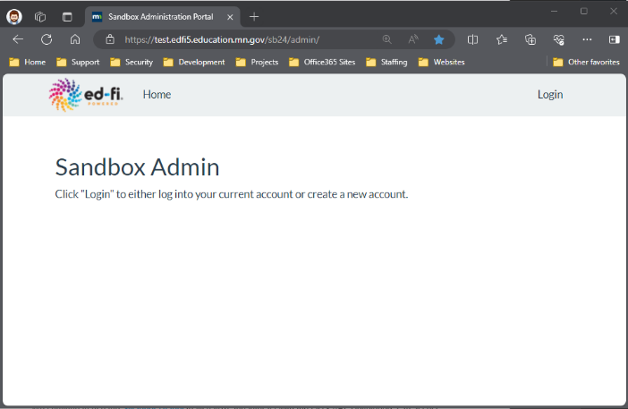
Ed-Fi Test Sandbox Administration Portal
MDE Sandbox Administration Site
As part of Sandbox certification, you will need access to the Ed-Fi Test Sandbox Administration Portal. To request an account, contact MDE by email. In the Sandbox Admin Site, you will be able to create ODS database instances to use for development and testing of your integrations.
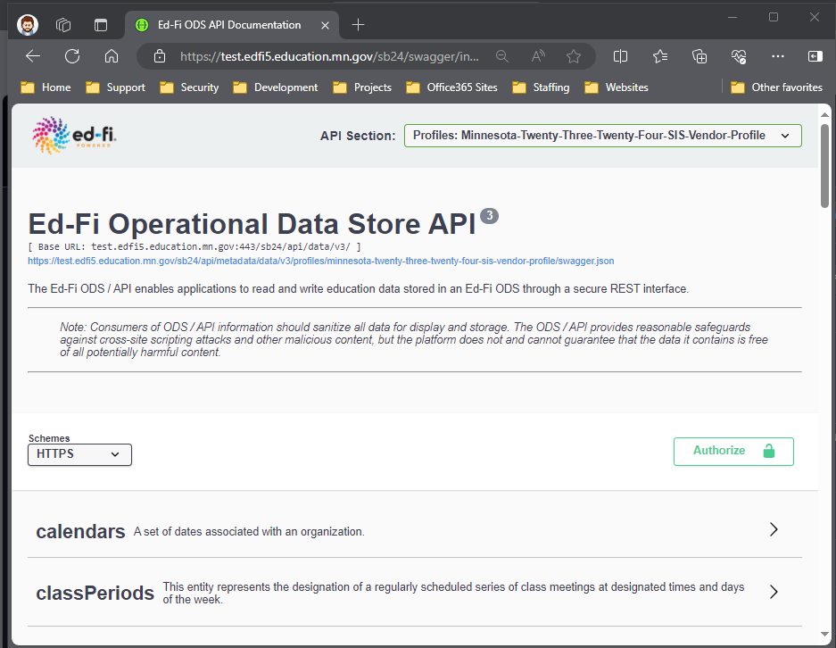
(See the Ed-Fi TechDocs Website for more detailed instructions on using the Ed-Fi Test Sandbox Administration Portal.)
Ed-Fi API Profile Selector

Ed-Fi Swagger Interface
Swagger Interface
Use the Ed-Fi Swagger interface to visualize and interact with MDE’s Ed-Fi API. Developers can access this user interface to test-drive Create, Read, Update, and Delete (CRUD) actions using MDE’s Ed-Fi API before building integrations as necessary.
All MDE-specific Ed-Fi API resources can be found under the Ed-Fi API profiles for each school year:
- Minnesota-Twenty-Five-Twenty-Six-SISVendor-Profile for data submitted to the school year 2025-2026 ODS
- Minnesota-Twenty-Six-Twenty-Seven-SISVendor-Profile for data submitted to the school year 2026-2027 ODS
Note: The Ed-Fi Identities API documentation is not available the Ed-Fi Swagger tool in the Ed-Fi Test Sandbox environment.

Minimal vs. Populated Test Sandbox ODS Databases
When creating a sandbox, you have the “populated” option of including a set of sample data in the sandbox. The sample database template is associated with St. Paul Public School District (LocalEducationAgencyId = 10625000). When you do not select the “populated” option to include sample data, your sandbox database will be loaded with an empty (“minimal”) ODS, except that it includes required data such as:
- Minnesota schools, districts, and other education organizations (from MDE-ORG)
- Descriptors customized for MDE’s Ed-Fi ODS/API
- Minnesota district programs for each program type
- Minnesota state course codes for Minnesota Common Course Catalog
NOTE: Due to the limited usefulness of the “populated” data set, the populated database template is no longer maintained but is still available as an option for creating test sandbox Ed-Fi ODS databases.
The actual SIS vendor certification test will be conducted in a “minimal” sandbox with no sample data loaded. SIS vendors will reference their own data in the test scenarios, relating elements to MDE schools, districts, and descriptors as needed.

Other Ed-Fi Test Sandbox Environment Helpful Tips
- In the Staging and Production environments, SIS vendor API keys will be associated with a claim set limiting access to only the API resources included in this document. This claim set has been enabled in the Sandbox environment. When you access a resource not included in the claim set, you will receive the following message in the response:
"Access to the resource could not be authorized. Are you missing a claim?”
- A SIS Vendor profile has been created limiting access to specific properties on each of the resources required in each school year. Profiles are tied to your key and secret and are auto-enabled in Staging and Production. This means that you will not have to include the profile in the “accept” or “content-type” headers of the request for the profile to take effect.

MDE Ed-Fi API Documentation

Browsing MDE’s Ed-Fi API Using the Ed-Fi Swagger Tool
For each of the resources described in this document, the elements/properties required are included and browsable in the Ed-Fi Swagger Tool ("Swagger") under the current profile.
For example, to view required properties for the studentSchoolAssociations resource, open the "POST" action in Swagger:
POST /ed-fi/studentSchoolAssociations: Creates or updates resources based on the natural key values of the supplied resource.
Note: "ed-fi" in the path above indicates that this is a core resource.
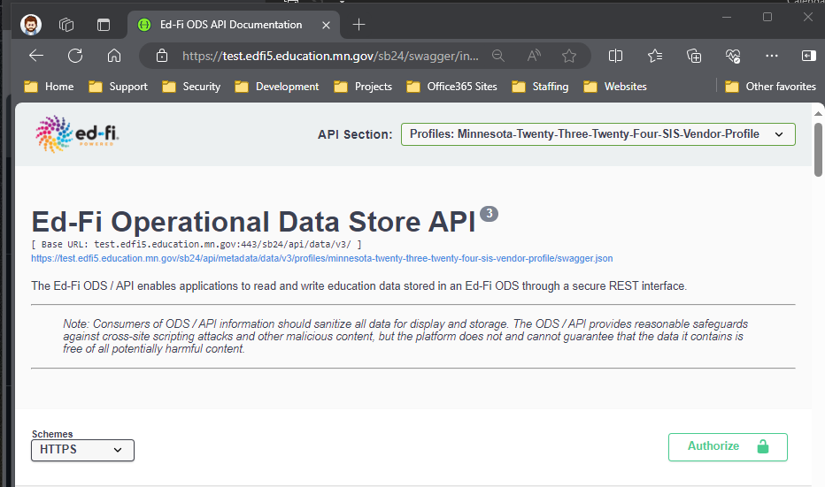
Select Ed-Fi API Profile
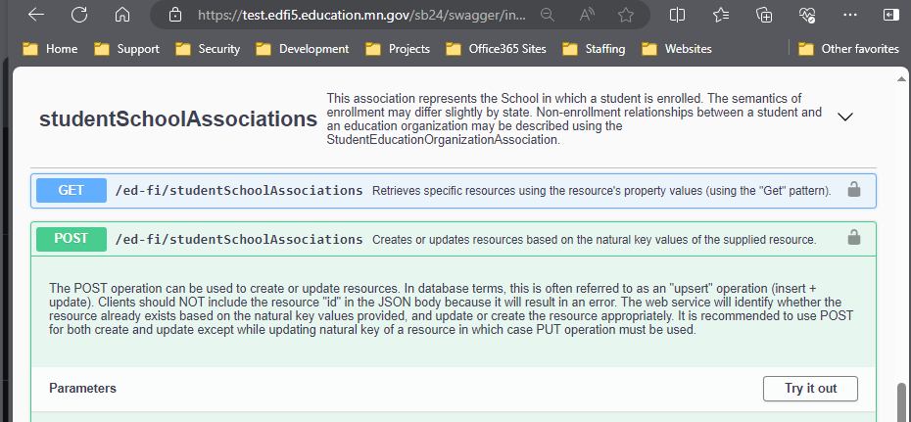
Scroll to find and expand the desired resource
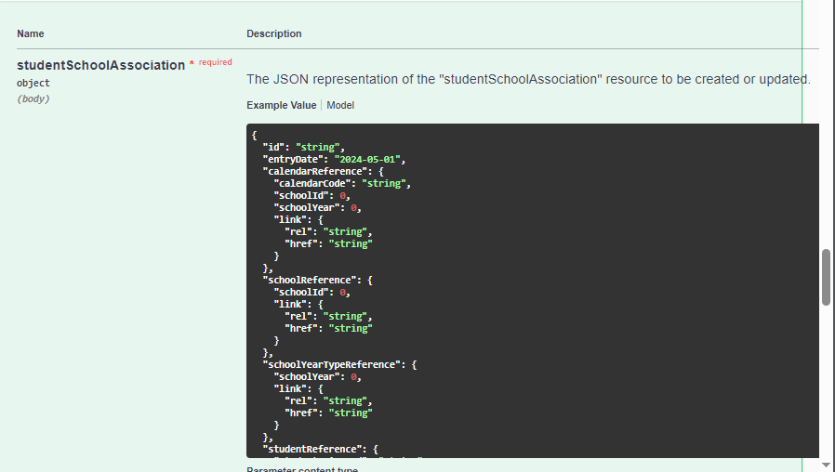
Select “Example Value” to view the resource properties as a sample JSON object template
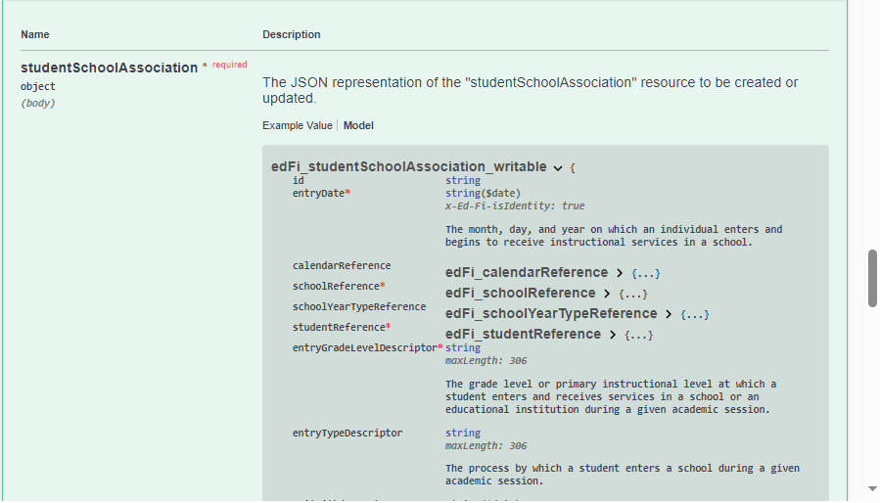
Select “Model” to view the resource property definitions and data types. Required properties are marked with a red asterisk.
Often, the actual data posting for an individual record can be much less than what is in the model. For example, compare the Swagger resource property sample below for a localEducationAgencyId reference with an actual JSON excerpt.

Swagger documentation excerpt:
"residentLocalEducationAgencyReference": {
"localEducationAgencyId": 0,
"link": {
"rel": “string”,
"href": “string”,
},
},
Actual JSON excerpt:
"residentLocalEducationAgencyReference": {
"localEducationAgencyId": 10625000
},

Mapping Documentation
See the Data Mapping Matrix spreadsheets in the “{YYYY-YY} MDE Ed-Fi Documentation” folders on MDE’s Ed-Fi Documentation GitHub site. These spreadsheets show how each data collection maps to the Ed-Fi Data Standard. Each school year's Data Mapping Matrix spreadsheet includes the mappings between MDE elements and Ed-Fi core and extension entities and elements.

Ed-Fi Descriptor References
See MDE’s Ed-Fi Documentation GitHub site for the list of MDE Ed-Fi API Descriptor Tables and additional documentation on Descriptors and Resources. In the Ed-Fi Swagger Tool, you can access the descriptor list by selecting “Descriptors” from the Ed-Fi API Profiles Selector.
MDE’s custom descriptor codes have been loaded under the namespace "uri://education.mn.gov/”. However, MDE does also use some default Ed-Fi descriptor codes with the namespace “uri://ed-fi.org/”. Check the descriptor tables for the correct descriptor namespace.
All descriptor references require namespaces and do not rely on the concept of a default operational context. Descriptor references must be formatted as follows:
uri://[organization indicator]/[name of descriptor]#[code value]
For example, below is a reference to the “Special Education” code value for the ProgramType descriptor:
uri://education.mn.gov/ProgramTypeDescriptor#Special Education

The following JSON excerpt is from the Minnesota extension of the studentSchoolAssociations resource. Note the usage of the membershipAttendanceUnitDescriptor and the transportationCategoryDescriptor.
"_ext": {
"MN": {
"homeboundServiceIndicator": true,
"specialPupilIndicator": true,
"residentLocalEducationAgencyReference": {
"localEducationAgencyId": 10625000
},
"membership": {
"membershipAttendanceUnitDescriptor": "uri://education.mn.gov/MembershipAttendanceUnitDescriptor#Days",
"attendance": 180,
"membership": 180,
"percentEnrolled": 100
},
"transportation": {
"transportationCategoryDescriptor": "uri://education.mn.gov/TransportationCategoryDescriptor#01",
"transportingLocalEducationAgencyReference": {
"localEducationAgencyId": 10625000
}
}
}
}

MDE Identifiers
Ed-Fi Identifier Name | MDE Identifier Name & Source System | Additional Information
StudentUniqueId | State Student ID  (Student ID System),  MARSS Number (MARSSWES) | See Ed-Fi Identities API for documentation on integration with MDE’s Student ID System to create new state student IDs.
EducationOrganizationId, LocalEducationAgencyId, SchoolId, PostSecondaryInstitutionId, StateEducationAgencyId | State Organization ID (MDE Organization Reference Glossary) | See MDE’s Ed-Fi Documentation GitHub site for documentation on Minnesota District and School IDs.  More information is available in MDE-ORG, including this reference on LEA (organization) types.
StaffUniqueId | File Folder Number / FFN (Educator Licensing System)
See MDE’s Ed-Fi Documentation GitHub site for the MDE Ed-Fi API requirements for EducationOrganizationId Usage by Resource.

Ed-Fi Model Dependency
Ed-Fi uses a data-dependency security model that enforces the order of creation when inserting various records via the API. This is often encountered via API errors such as the following:
Authorization denied. The claim does not have any established relationships with the requested resource.
See MDE’s Ed-Fi Documentation GitHub site for Ed-Fi Model Dependency Graphs demonstrating the dependencies of various data resources in MDE’s Ed-Fi API.

Read-Only Ed-Fi API Endpoints
Several of the required Ed-Fi API data elements are loaded by MDE into the Ed-Fi ODS and are read-only to the SIS Vendor API profiles. This section details those elements.

Resource: /ed-fi/localEducationAgencies
This entity represents an administrative unit at the local level which exists primarily to operate schools or to contract for educational services. It includes school districts, charter schools, or other local administrative organizations.
All local education agency organization data required for Ed-Fi is loaded into the ODS from MDE-ORG.

Resource: /ed-fi/schools
This entity represents an educational organization that includes staff and students who participate in classes and educational activity groups.
All school organization data required for Ed-Fi is loaded into the ODS from MDE-ORG.

Resource: /ed-fi/postSecondaryInstitutions
An organization that provides educational programs for individuals who have completed or otherwise left educational programs in secondary school(s).
All postsecondary institution organization data required for Ed-Fi is loaded into the ODS from MDE-ORG.

Resource: /ed-fi/programs
This entity represents any program designed to work in conjunction with, or as a supplement to, the main academic program. Programs may provide instruction, training, services, or benefits through federal, state, or local agencies. Programs may also include organized extracurricular activities for students.
Program data records are created for each appropriate program type, for each organization, as part of the organization data load into the ODS from MDE-ORG.

Resource: /ed-fi/courses
This educational entity represents the organization of subject matter and related learning experiences provided for the instruction of students on a regular or systematic basis.
The MCCC State Course Catalog courses are loaded for the state education agency (EducationOrganizationId = 999999000) into the ODS by MDE.

Resource: /ed-fi/staffs
This entity represents an individual who performs specified activities for any public or private education institution or agency that provides instructional and/or support services to students or staff at the early childhood level through high school completion.
Licensed educator records are loaded from the Educator Licensing system into the ODS by MDE for referencing in MCCC staffSectionAssociations.

